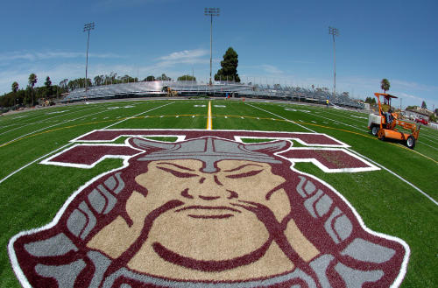
z

Events and Order:
5000m – (combined race)
4x800
8x200
1600m
1600 SMR - (3,3,6,4)
1000m
800 SMR - (1,1,2,4)
DMR
Pole Vault
Shot Put
Disc
L.J.
T.J.
H.J.

Medals: top 3 overall in each event, per division, except 1600 & 5000.

Entries: EPI Sports
Deadline:
Thursday, 2/17/2022 - 11 PM.

Team Entry Fee: $250
Checks: THS Track
Due:
Tuesday, 2/15/2022

Mail: Kyle Irvine
THS Track and Field
2200 W. Carson St.
Torrance 90501

DIRECTIONS TO ZAMPERINI

See Map Below - page 4

Contact:
Kyle Irvine
310-283-1878 - cell
Isa4522@startmail.com

Louis Zamperini Invitational
February, 19, 2022
Zamperini Stadium:
2320 Crenshaw Bl.
Torrance, CA 90501

Start Time:
5000m – 9:15am
4x800 follows 5000m
Field Events – 9:00am

Team Entry Fee: $250

Unlimited entries per event
Relay teams (A – Z)

www.thstf.com/zamperini
www.thstf.com/directions

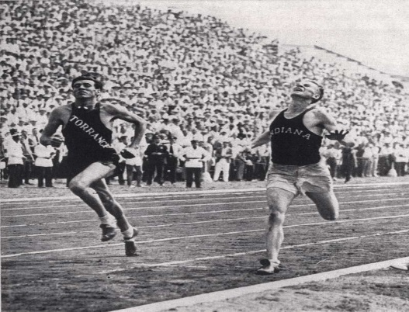

Louis Zamperini Invitational

Where: Zamperini Stadium
2320 Crenshaw Bl.
Torrance, Ca. 90501

Date: Saturday - February 19, 2022

Start Time: 9:15 am – 5000m
4x800 follows 5000m
Field Events - 9:00am

Levels: Varsity & F/S - Boys & Girls

Events: Zamperini 5000m (one race combined), 1600m (two races)

Relays:
4x800 – 4 races (one race per level) no heats
8x200
1600 SMR (3, 3, 6, 4)
800 SMR (1, 1, 2, 4)
DMR – two races (combined girls / combined boys)

Field Events: PV, SP, DISC, HJ, LJ, TJ

Medals: top 3 overall in all events
Exception: 1600m & 5000m top 6 each race will receive trophies

Entries: Entries online at EPI Sports – Unlimited in all events
Deadline - Thursday 2/17/22 - 11pm

Entry Fee - $ 250.00 per team (make check out to THS Track) due by Tuesday, Feb 15, 2022

Mail: THS Track & Field - Attn: Kyle Irvine
2200 W. Carson St.
Torrance, Ca. 90501

Website: www.thstf.com - click Zamperini Tab on home page

Contact: Kyle Irvine – (310) 283-1878 or isa4522@startmail.com

Approximate:

Event #1 5000m – Boys / Girls 9:15am Event #27- Pole Vault – 9:00am

Event #2 4x800 – F/S -Boys 9:45am Opening Height – 5’5” – F/S – G
7’ 0” – V/G
Event #3 4x800 – F/S - Girls 10:05am 8’ 0” – F/S - B
10’ 0” – V/B
Event #4 4x800 – Varsity – Girls 10:25am
Event #28 – High Jump – (Two Pits) 9:00am
Event #5 4x800 – Varsity – Boys 10:40am
Opening Heights – 3’ 8” / 4’8”
Event #6 8x200 – F/S - Boys 11:00am
Event #29 Long Jump Two Pits
Event #7 8x200 – F/S Girls 11:10am
Varsity Boys 9:00am #1
Event #8 8x200 – Varsity – Girls 11:20am Varsity Girls 9:00am #2
F/S – Boys 10:45am #1
Event #9 8x200 – Varsity – Boys 11:30am F/S – Girls 10:45am #2

Event #10 1600m – Boys 11:40pm Event #30 Triple Jump

Event #11 1600m – Girls 12:00pm Varsity Boys 12:00pm #1
Varsity Girls 12:00pm #2
Event #12 1600 SMR – F/S – Boys 12:30pm F/S – Boys 1:30pm #1
F/S – Girls 1:30pm #2
Event #13 1600 SMR – F/S – Girls 12:40pm

Event #14 1600 SMR – Var Girls 12:50pm Event #31- Shot Put 9:00am

Event #15 1600 SMR – Var Boys 1:00pm V/B
F/S - B
Event #16 1000m – F/S - Boys 1:15pm F/S - G
V/G
Event #17 1000m – F/S Girls 1:25pm
Event #32 – Discus 9:00am
Event #18 1000m - Var Girls. 1:35pm
V/G
Event #19 1000m Var - Boys 1:50pm F/S - G
F/S - B
Event #20 800 SMR F/S - Boys 2:00pm V/B

Event #21 800 SMR F/S - Girls 2:15pm

Event #22 800 SMR – Var Girls 2:30pm

Event #23 800 SMR – Boys 2:45pm

Event #24 DMR - Girls 3:00pm

Event #25 DMR - Boys 3:30pm

