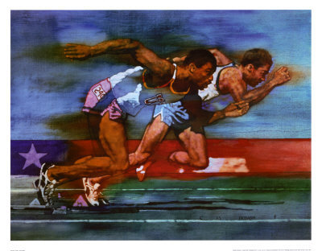

Coach Kyle Irvine

310-283-1878

isa4522@startmail.com

**2022** **TEAM TRYOUTS**

Events:

**Sprints/Hurdles**

**High Jump**

**Long Jump**

**Triple Jump**

**Shot Put**

**Discus**

**Pole Vault**

**Distance**

**Must be Cleared by the Athletic Director**

**Must Be Eligible**

**Mandatory for all students**

**Returners Must Try Out**

**Attend a Lunch Meeting for Information**

**Tryout Location:**

**Zamperini Stadium**

**New Students/Fall Sports/Returners** Saturday, December 4, 2021 **Time: 10am – 1pm**

**Winter Sports:**

Saturday, February 5, 2022

**Time: 10am – 1pm**

**Attend Lunch Meeting for more information**

**THS TRACK AND FIELD**

**Lunch Meeting: 12:30pm**

**Wednesday, November 17, 2021**

**Location will be published in the school daily bulletin**

**www.thstf.com /calendar**

[**www.thstf.com/**](http://www.thstf.com/) **try-outs**