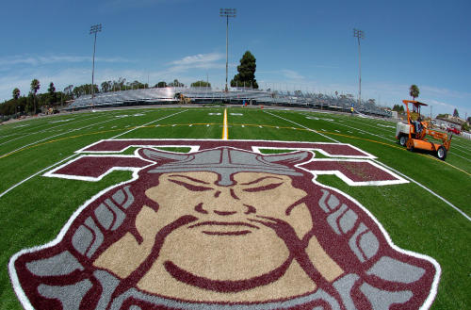
z

Events and Order:
5000m – 9:30am
4x800
8x200
1600
SMR
1000m
SMR-800
DMR
Pole Vault
Shot Put
Disc
L.J.
T.J.
H.J.

Medals: top 3 overall in each event, per division, except 1600 & 5000.

Entries: EPI Sports
Deadline: Thursday 2/20/2020 - 11 PM.

Entry Fee: $200 – Team
Due: Tuesday 2/18/2020
Checks: THS Track

Mail: Kyle Irvine
THS Track and Field
2200 W. Carson St.
Torrance 90501

DIRECTIONS TO FIELD:
Traveling north or south on 405 Freeway take Crenshaw off-ramp south to Carson Street. Turn left and continue to Plaza del Amo (1st signal). Turn right on Plaza Del Amo and continue past the back of the school to Arlington Street. Turn right on Arlington, go to the first street past the railroad tracks (Lincoln St.) and turn right on to Lincoln. Proceed on Lincoln to the athletic field, which is across from Torrance Elementary School.

Contact:
Kyle Irvine
310-283-1878 - cell
Isa4522@startmail.com

Louis Zamperini Invitational
February, 22, 2020
Zamperini Stadium:
2125 Lincoln Ave.
Torrance, CA 90502

Start Time:
Zamperini 5000m – 9:30am
Field Events: 9:30am
4x800 follows 5000m

Entry Fee: $200 entire team

Unlimited entries per event
Relay teams (A – Z)

www.thstf.com/zamperini
www.thstf.com/directions

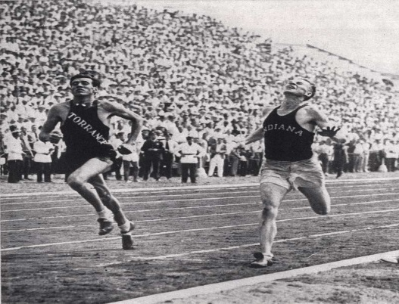

Louis Zamperini Invitational

Where: Zamperini Stadium
2125 Lincoln Ave.
Torrance, Ca.

Directions: www.thstf.com/directions

Format: Early season meet to honor the legacy of Louis Zamperini.

Date: Saturday - February 22, 2020

Start Time: 9:30 am – 5000m
Field Events – 9:30am
4x800 follows 5000m

Levels: Varsity & F/S - Boys & Girls

Events: Zamperini 5000m (one race combined), 1600m (two races), 1000m (two races)

Relays:
4x800 – 4 races (one race per level) no heats
8x200
1600 SMR (3, 3, 6, 4), 800 SMR (1, 1, 2, 4)
DMR – two races (combined girls / combined boys) no heats

Field Events: PV, SP, DISC, HJ, LJ, TJ

Medals: top 3 overall in all events,
Exception: 1600m & 5000m top 3 each race will receive trophies

Entries: Entries online at EPI Sports – Unlimited in all events
Deadline - Thursday 2/20/20 - 11pm

Entry Fee - $ 200.00 per team (make check out to THS Track) due by Tuesday, Feb 18, 2020.

Mail: THS Track & Field - Attn: Kyle Irvine
2200 W. Carson St.
Torrance, Ca. 90501

Website: www.thstf.com - click Zamperini Tab on home page

Contact: Kyle Irvine – (310) 283-1878 or isa4522@startmail.com

Order of Events: Running Field: 9:30am (see below)
5000m – 9:30am Pole Vault
4x800 – follows Shot
8x200 Disc
1600m H.J.
SMR - 1600 L.J.
1000m T.J. – follows completion of Long Jump
SMR – 800
DMR

Approximate:

Event #1 5000m – Boys / Girls 9:30am Event #27- Pole Vault – 9:30am

Event #2 4x800 – F/S -Boys 10:00am Opening Height – 5’5” – F/S – G
7’ 0” – V/G
Event #3 4x800 – F/S - Girls 10:20am 8’ 0” – F/S - B
10’ 0” – V/B
Event #4 4x800 – Varsity – Girls 10:45am
Event #28 – High Jump – (Two Pits) 9:30am
Event #5 4x800 – Varsity – Boys 11:00am
Opening Heights – 3’ 8” / 4’8”
Event #6 8x200 – F/S - Boys 11:20am
Event #29 Long Jump Two Pits
Event #7 8x200 – F/S Girls 11:30am
Varsity Boys 9:30am #1
Event #8 8x200 – Varsity – Girls 11:40am Varsity Girls 9:30am #2
F/S – Boys 11:15am #1
Event #9 8x200 – Varsity – Boys 11:50am F/S – Girls 11:15am #2

Event #10 1600m – Boys 12:00pm Event #30 Triple Jump

Event #11 1600m – Girls 12:30pm Varsity Boys 1:00pm #1
Varsity Girls 1:00pm #2
Event #12 1600 SMR – F/S – Boys 1:00pm F/S – Boys 2:30pm #1
F/S – Girls 2:30pm #2
Event #13 1600 SMR – F/S – Girls 1:10pm

Event #14 1600 SMR – Var Girls 1:25pm Event #31- Shot Put 9:30am

Event #15 1600 SMR – Var Boys 1:35pm V/B
F/S - B
Event #16 1000m – Boys 1:45pm F/S - G
V/G
Event #17 1000m – Girls 2:00pm
Event #32 – Discus 9:30am
Event #18 800 SMR – F/S – Boys 2:15pm
V/G
Event #19 800 SMR – F/S- Girls 2:25pm F/S - G
F/S - B
Event #20 800 SMR Var Girls 2:35pm V/B

Event #21 800 SMR Var Boys 2:45pm

Event #22 DMR – Girls 2:55pm

Event #23 DMR – Boys 3:20pm

